Project Design Phase-II
Data Flow Diagram & User Stories

Date | 26 June 2026
Team ID
Project Name | Metro Ticket Generating System in ServiceNow
Maximum Marks | 4 Marks

Data Flow Diagrams: A Data Flow Diagram (DFD) is a traditional visual representation of the information flows within a system. A neat and clear DFD can depict the right amount of the system requirement graphically. It shows how data enters and leaves the system, what changes the information, and where data is stored.
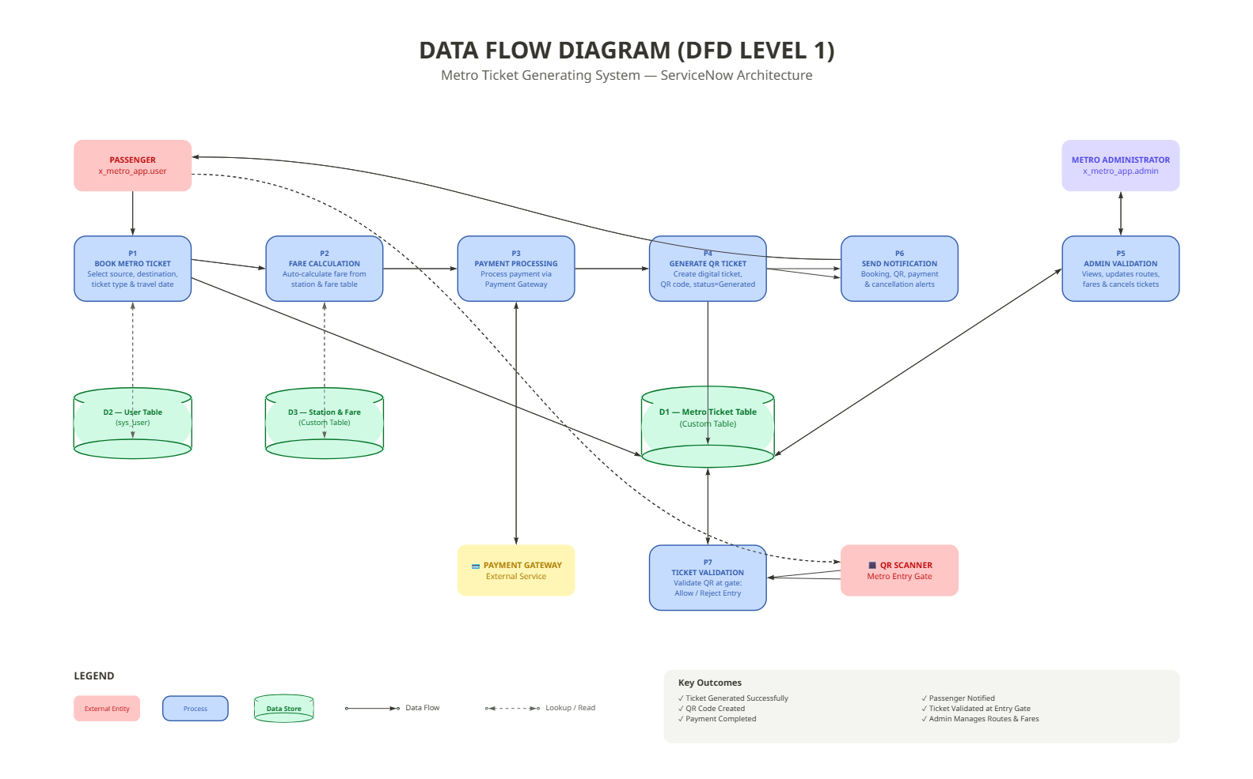

User Stories
Use the below template to list all the user stories for the product.
User Story Backlog – Metro Ticket Generating System
User Type | Functional Requirement (Epic) | User Story Number | User Story / Task | Acceptance Criteria | Priority | Release
Customer (Mobile/Web User) | Registration & Login | USN-1 | As a passenger, I can register and log in using my email and password. | User can successfully register and access the dashboard. | High | Sprint-1
 | Search Metro Route | USN-2 | As a passenger, I can select source and destination stations to search available routes. | Correct route and station details are displayed. | High | Sprint-1
 | Fare Calculation | USN-3 | As a passenger, I want the system to calculate the ticket fare automatically. | Fare is calculated accurately based on selected stations. | High | Sprint-1
 | Book Metro Ticket | USN-4 | As a passenger, I can book a metro ticket by selecting journey details. | Ticket request is created successfully. | High | Sprint-2
 | Online Payment | USN-5 | As a passenger, I can pay for my metro ticket using online payment methods. | Payment is processed successfully and transaction is recorded. | High | Sprint-2
 | QR Ticket Generation | USN-6 | As a passenger, I receive a QR-based digital metro ticket after successful payment. | QR ticket is generated and available in My Tickets. | High | Sprint-2
 | Ticket History | USN-7 | As a passenger, I can view my previous and current metro tickets. | Ticket history is displayed correctly. | Medium | Sprint-3

